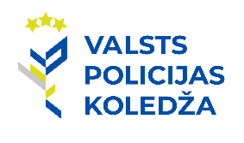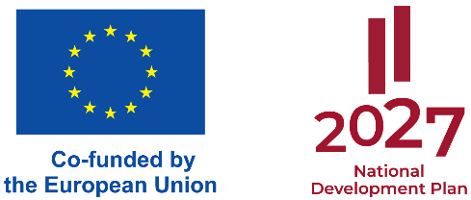

***INVITATION***

Within the European Union Internal Security Fund Project No. VP/IDF/2024/5 **“**Strengthening the Mobility Response and Counter-Terrorism Capacity of the State Police through the Establishment of a Practical Training Centre” the State Police College organises the conference **“Managing the Terrorism Threat: Effectiveness, Cooperation and Preparedness of Police and Intervention Units”,** which will take place from November 20, 2024 to November 21, 2024, in Riga, Latvia.

Main discussion topics of the conference:

* Cooperation of police and security authorities in the fight of terrorism.
* Examples of good practice in cooperation and training.
* Effective use of integrated security tactics in terrorist threat situations.
* Staff preparedness and training in the context of the latest terrorist threats.
* Psychological preparedness and resources for effective counter terrorist threats.
* Real situations and examples of good practice in terrorism investigations.

The venue of the conference: FANTADROMS, G. Zemgala gatve 74a, Riga, Latvia, HENRIHS office building.

The working languages of the conference: English and Latvian. Interpretation will be provided.

Participation in the conference is possible in person and remotely.

Please inform on participants by October 4, 2024, by filling in the form: <https://docs.google.com/forms/d/e/1FAIpQLSfiY-KhMIalQi76dJMJ86zXbPmySPXXMHwVNlZCNkNnfehGUg/viewform?vc=0&c=0&w=1&flr=0>

For additional information please contact us electronically by writing to the e-mail: [cooperation@koledza.vp.gov.lv](mailto:cooperation@koledza.vp.gov.lv)

We are looking forward to welcoming you in Riga!