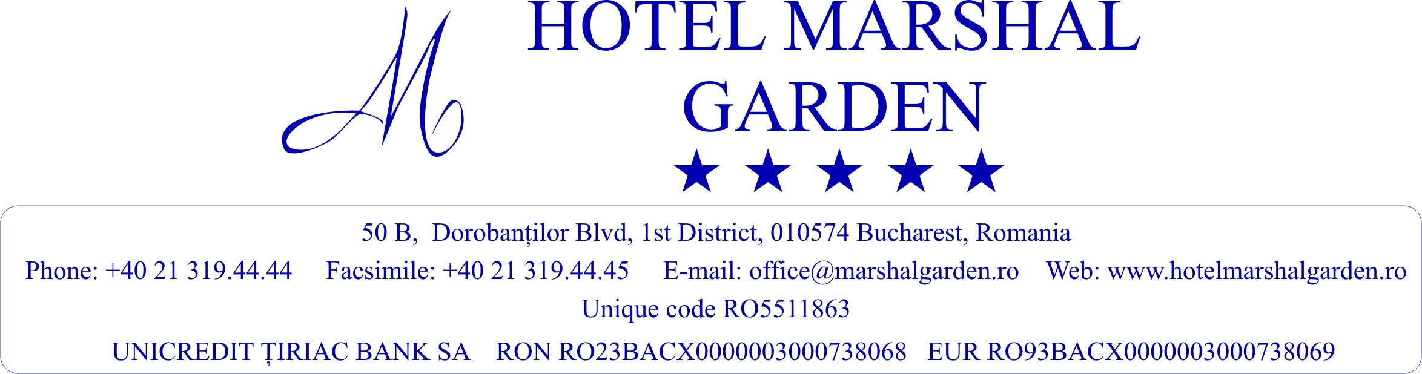

RESERVATION FORM

ACCOMMODATION SERVICES:
Name/ Surname |  | Telephone
Company |  | E-mail address
Arrival date |  | Credit card type
Departure date |  | Credit card number
No. of rooms/  Room type |  | Validity date
Address |  | CVC NO
 |  | Name on card

Please mark your option regarding the hotel reservation and fill the requested data:

HOTEL MARSHAL GARDEN 5*
Special Rates for the participants
Migration in a Changing World
valid for period 28th of May- 30th of May, 2025

Local taxes (VAT and city tax) are subject to Governmental change without any further notice.
Accommodation

Booking period/ no. of nights | tARIFF/ ROOM TYPE  (includes: breakfast, in room coffee&tea making facilities, wifi, vat, taxes)
 | 100 eur/ single room/ night | 125 eur/ double room/ night
TOTAL AMOUNT OF SERVICES REQUESTED FOR BOOKING

I hereby undertake to settle in charges for accomodation with “Marshal Garden Hotel”

Signed:_____________________

Date:___________________________

NOTICE:

Reservations can be modified or canceled until 10th of May without penalties.
In case of guest „no show”, the payment for one night accommodation will be charged at the room rate confirmed and the reservation will be entirely cancelled.

Rooms Reservation will be confirm upon hotel availability.
Payment will be done at check-in.
In case of payment in advance by banking transfer, please send us the information for the invoice.

Beneficiary name: MARSHAL TURISM SRL – Sucursala Dorobanti
(HOTEL MARSHAL GARDEN)
50B, Calea Dorobantilor, Bucharest, Romania
Tel. / Fax: 0040 – 21 – 319.44.44/ 45
www.hotelmarshalgarden.ro;

Please send the Reservation Form to:
Adrian MOCANU – Hotel Manager (Contact person)
E-mail: office@marshalgarden.ro; adrian.mocanu@marshalgarden.ro

